Q2 – User-Defined Exceptions and Propagation in an Online ExaminationPortal 7Marks
Bloom’s Level: K4 – Analyse
Problem Context – Online Examination Portal
An online examination portal must reject a submission if the exam window has closed, if the student is not registered for the course, or if the answer file exceeds the size limit. These rules are checked in different layers: the controller, the service and the storagelayer.
Shared Group Work
Together:
• Design a hierarchy of user-defined exceptions for the portal (for example: ExamException with subclasses)
• Decide which exceptions are checked and which are unchecked • Implement throw and throws across the three layers
• Implement exception chaining so that the original cause is not lost
Student A – Exception Hierarchy and Propagation Design Student A must individually:
• Represent the exception hierarchy as a class diagram • Explain the reason for making each exception checked or unchecked • Draw the propagation path of one exception from the storage layer to the controller
• Explain where the exception is finally handled and what message the student sees
Student B – Failure Scenarios and Chaining Evidence
Student B must individually:
• Construct one scenario for each exception
• Demonstrate exception chaining using getCause() and show the full chained stack trace
• Show what information is lost if the exception is re-thrown without its cause • Record the observed behaviour in a test table
Joint Conclusion
Why is it better for the storage layer to throw a meaningful
SubmissionStorageException than to let an IOException travel unchanged to the user interface?
Complete the Code
Complete TODO 1 below and execute the program.

import java.io.IOException;
class ExamException extends Exception {
ExamException(String message) { super(message); }
ExamException(String message, Throwable cause) { super(message, cause); }}
class SubmissionStorageException extends ExamException { SubmissionStorageException(String message, Throwable cause) { super(message, cause);
}
}
class Storage {
void save(String fileName, long sizeKb) throws SubmissionStorageException {try {
if (sizeKb > 500) throw new IOException("Disk quota exceeded");
System.out.println("Saved " + fileName);
} catch (IOException e) {
// TODO 1: Wrap the IOException in a SubmissionStorageException, keeping// IOException as its cause
}
}
}
public class StorageDemo {
public static void main(String[] args) {
Storage storage = new Storage();
try {
storage.save("answer01.pdf", 120);
storage.save("answer02.pdf", 800);
} catch (ExamException e) {
System.out.println("Error: " + e.getMessage());
System.out.println("Cause: " + e.getCause().getMessage()); }
}
}

Expected output:
Saved answer01.pdf
Error: Could not store answer02.pdf
Cause: Disk quota exceeded

the
Explain what would be printed in the Cause line if the IOException were not passedtothe constructor.
Alternative Concept and Complexity Analysis
Your custom exceptions are checked. If they were made unchecked (extendingRuntimeException), what would change in the method signatures and in the calling code?Analyse the time and space cost of capturing a stack trace for each exception and howchaining affects the memory held by one exception object.

Answer:
TODO1 COMPLETED CODE:

import java.io.IOException;

class ExamException extends Exception {
ExamException(String message) {
super(message);
}

ExamException(String message, Throwable cause) {
super(message, cause);
}
}

class SubmissionStorageException extends ExamException {
SubmissionStorageException(String message, Throwable cause) {
super(message, cause);
}
}

class Storage {
void save(String fileName, long sizeKb)
throws SubmissionStorageException {

try {
if (sizeKb > 500) {
throw new IOException("Disk quota exceeded");
}

System.out.println("Saved " + fileName);

} catch (IOException e) {

// TODO 1 completed: preserve the original IOException
throw new SubmissionStorageException(
"Could not store " + fileName, e
);
}
}
}

public class Main {
public static void main(String[] args) {

Storage storage = new Storage();

try {
storage.save("answer01.pdf", 120);
storage.save("answer02.pdf", 800);

} catch (ExamException e) {

System.out.println("Error: " + e.getMessage());
System.out.println("Cause: " + e.getCause().getMessage());
}
}
}
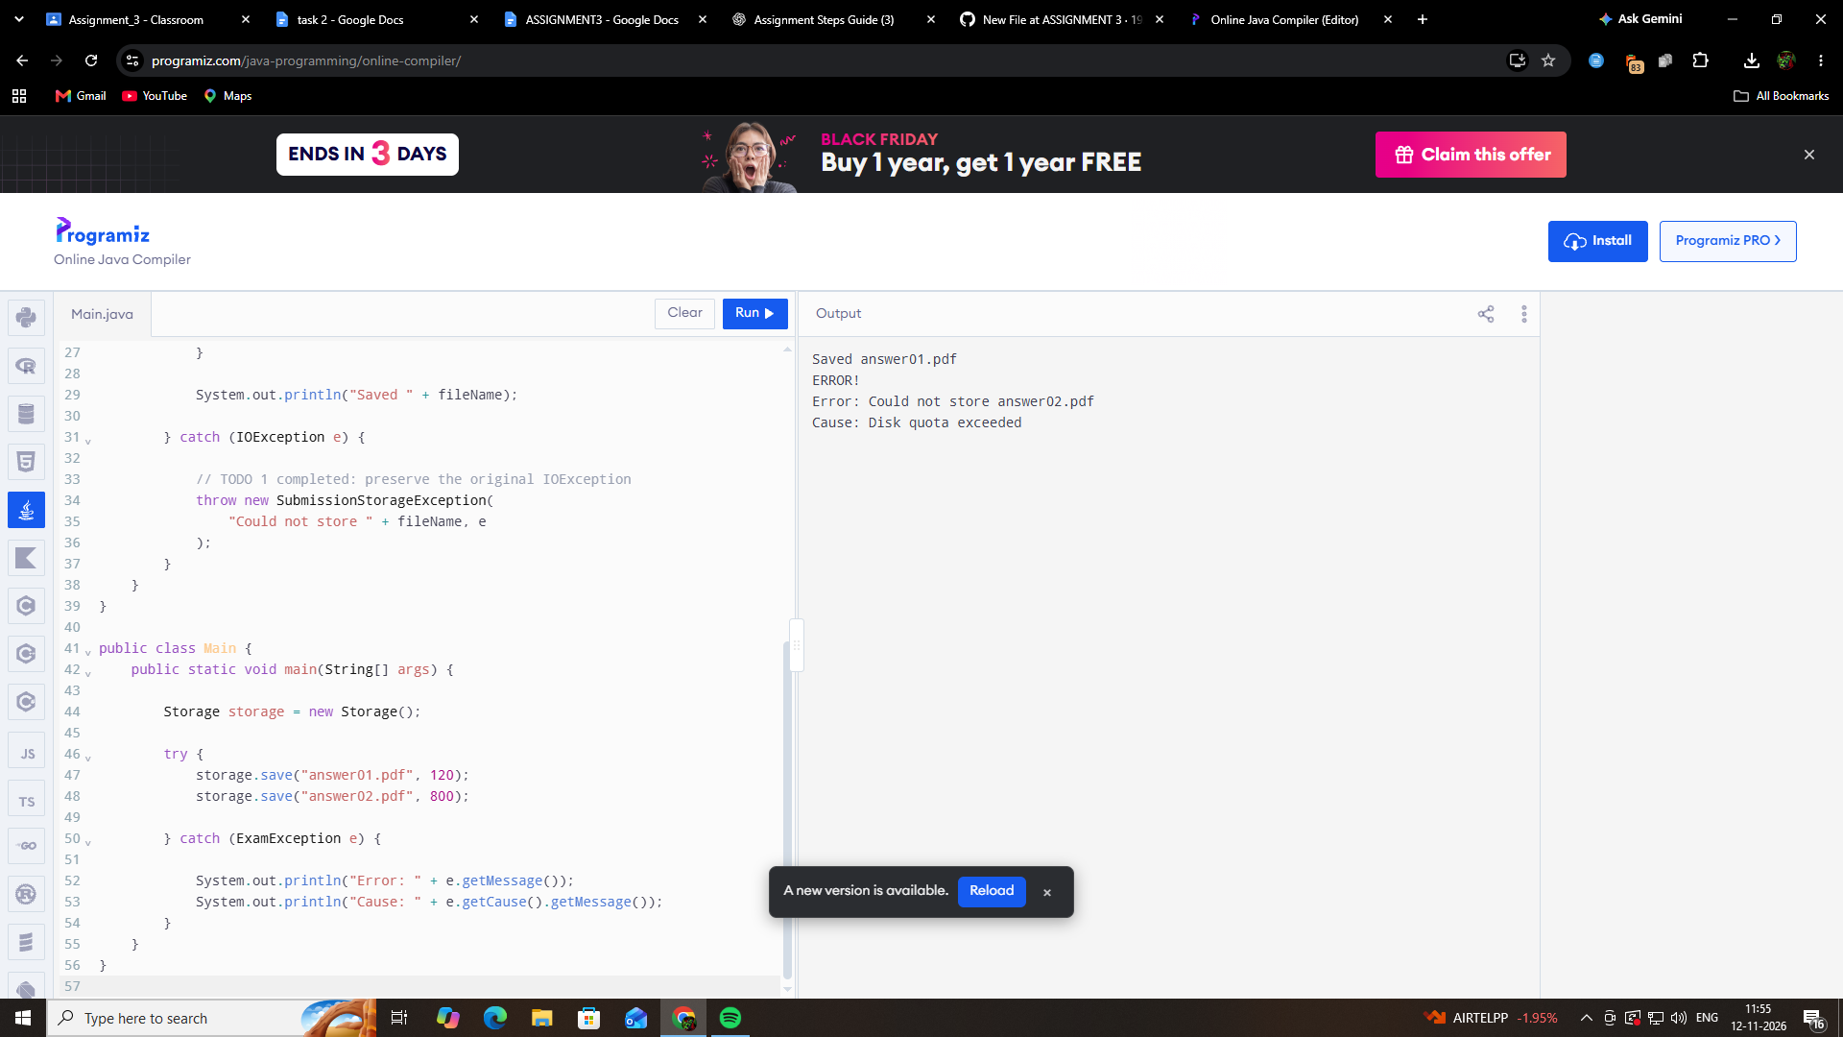

Exception hierarchy:
Throwable
|
Exception
|
ExamException (Custom checked exception)
|
SubmissionStorageException

import java.io.IOException;

// Parent custom checked exception
class ExamException extends Exception {
ExamException(String message) {
super(message);
}

ExamException(String message, Throwable cause) {
super(message, cause);
}
}

// Custom exceptions for portal failures
class ExamClosedException extends ExamException {
ExamClosedException(String message) {
super(message);
}
}

class StudentNotRegisteredException extends ExamException {
StudentNotRegisteredException(String message) {
super(message);
}
}

class FileTooLargeException extends ExamException {
FileTooLargeException(String message) {
super(message);
}
}

class SubmissionStorageException extends ExamException {
SubmissionStorageException(String message, Throwable cause) {
super(message, cause);
}
}

// Storage layer
class Storage {
void save(String fileName, long sizeKb, boolean diskFailure)
throws SubmissionStorageException {

try {
if (diskFailure) {
throw new IOException("Disk quota exceeded");
}

System.out.println("Saved " + fileName);

} catch (IOException e) {
throw new SubmissionStorageException(
"Could not store " + fileName, e
);
}
}
}

// Service layer
class ExamService {
Storage storage = new Storage();

void submit(String fileName, long sizeKb,
boolean examOpen, boolean registered,
boolean diskFailure) throws ExamException {

if (!examOpen) {
throw new ExamClosedException(
"The exam window is closed."
);
}

if (!registered) {
throw new StudentNotRegisteredException(
"Student is not registered for this course."
);
}

if (sizeKb > 500) {
throw new FileTooLargeException(
"Answer file exceeds the 500 KB limit."
);
}

storage.save(fileName, sizeKb, diskFailure);
}
}

// Controller layer
class ExamController {
ExamService service = new ExamService();

void handleSubmission(String fileName, long sizeKb,
boolean examOpen, boolean registered,
boolean diskFailure) {

try {
service.submit(fileName, sizeKb,
examOpen, registered, diskFailure);

} catch (ExamException e) {
System.out.println("Error: " + e.getMessage());

if (e.getCause() != null) {
System.out.println(
"Cause: " + e.getCause().getMessage()
);
}
}
}
}

// Main class
public class Main {
public static void main(String[] args) {

ExamController controller = new ExamController();

System.out.println("TEST 1: Exam window closed");
controller.handleSubmission(
"answer01.pdf", 100, false, true, false
);

System.out.println("\nTEST 2: Student not registered");
controller.handleSubmission(
"answer02.pdf", 100, true, false, false
);

System.out.println("\nTEST 3: File exceeds size limit");
controller.handleSubmission(
"answer03.pdf", 800, true, true, false
);

System.out.println("\nTEST 4: Storage failure");
controller.handleSubmission(
"answer04.pdf", 100, true, true, true
);
}



